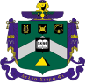
Delta Sigma Phi Alumni
SLO / CA / Alumni Newsletter
Issue #24: Spring/Summer 2021
Brother Chris "Yabut" Patterson, W'73, Editor,
cpatterson76@outlook.com

This Issue's Theme:


Our Unique Bond-Of-Brotherhood

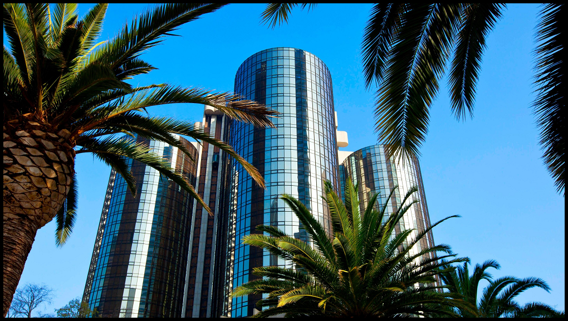

Photo: The downtown Los Angeles Westin Bonaventure Hotel - site of DSP's biennial National Convention this October 14th-16th.

A large attendance by Cal Poly Epsilon Rho alumni will: (1) encourage National to continue chapter restart efforts; (2) thank Lurch for his service as he terms-out of office as National President ; (3) take advantage of the first in-state convention in decades to gather and celebrate our chapter's brotherhood - and experience the National Brotherhood and meet like-minded alumni!

In This Issue..........


National Fraternity President's Message: Our Biennial National Convention Will Be Held In-Person This October In LA



Chapter Restart Efforts Continue

(EDITORIAL) Providence Provides Cal Poly Delta Sigs The Opportunity To Promote Chapter Return

ACB Meeting and Elections - Spring 2021

Bond Eternal

A Brother's Memories of Mustang Aviation and Our Fire Engine


Origin of Our Chapter's Al Capone Party

Invitation To Charity BBQ and Golf Tournament

Save These Dates

One Class-Rep Sought For Each Pledge Class


AA Needs Your Support To Continue Our Work

National Fraternity President's Message: Our Biennial National Convention Will
Be Held In-Person This October in LA

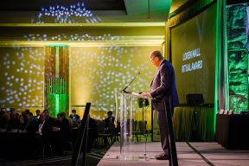
Brothers:

I am thrilled to announce that Delta Sigma Phi's 63rd National Convention will take place from October 14-16 in Los Angeles, California! The event will be held in-person, but we plan to have virtual options available as well.

Given the impact of the pandemic, we were unsure if our brotherhood would be able to come together for our Biennial Convention - for context, the last time our Convention was not able to move forward was in 1942 during World War II. However, after evaluating our options with hundreds of undergraduate and alumni members, and in partnership with the Los Angeles Department of Convention & Tourism Development, we feel confident that the move to October will provide the best possible opportunity for brothers to have a fun, safe, and memorable experience.
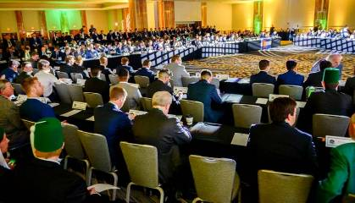
We are incredibly thankful for the work of our undergraduate and alumni members, our campus partners, and the countless medical professionals who have played a role in supporting Delta Sigma Phi through the pandemic. If anything, this socially distant year has reaffirmed the value of meaningful friendships that are made possible by fraternal organizations.

So, what happens next? Save the date! Then, over the coming weeks and months, be on the lookout for announcements and pre-Convention programming that will lead to a heck of a celebration in Los Angeles!

YITBOS,

Jim Larson
National President, Delta Sigma Phi Fraternity
Cal Poly, San Luis Obispo

Chapter Restart Efforts Continue
By Jim "Lurch" Larson, W'72

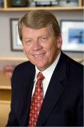
Our National Fraternity has been working diligently since 2018 to bring Epsilon Rho back to Cal Poly.
In the fall 2018/spring 2019, the National organization, in collaboration with the ACB, worked to stop any independent efforts of the former chapter based on documented evidence from the university, social media and police reports which we all agreed upon were occurring. During this time, the University stated that we had not met the obligation of fully closing and therefore the suspension clock had not started.
After months of efforts to cease rogue operations and numerous conversations with the university, we satisfied all of the University’s requirements for return after completing our suspension.
In the spring of 2020 (pre-COVID), ACB and National prepared for our return, however, the pandemic stopped all expansions and the IFC expansion process.
In the fall of 2020, the expansion process at Poly started again and the ACB and National Fraternity presented to Cal Poly and the IFC. Poly took ten weeks to get back to us regarding the process and ultimately shared that while we were recommended by the University administration, we were not slated to return by the IFC, which the University has empowered to chose expansion organizations, despite “agreements and assurances” with the University prior to the vote that we would be a chosen organization.
Following this unexpected setback, National is initiating a series of next steps including an appeal process, pressing for another early IFC vote and engaging with fraternal peers as we continue the conversation with the University to be assured re-entry in the fall of 2022.

(EDITORIAL)
Providence Provides Cal Poly DSP Alums Opportunity To Promote Chapter Return
By Chris "Yabut" Patterson, W'73

My fellow Cal Poly Delta Sig alumni, providence is providing us a timely opportunity, close to home, to promote our chapter's return!

For the first time in over 25 years our Delta Sigma Phi biennial National Convention will be held in California! To provide context, the prior five conventions were held in St. Louis (2011), Phoenix (2013), New Orleans (2015), Baltimore (2017), and Kansas City (2019).

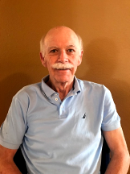
Each convention draws together National Fraternity officers and staff, and alumni and undergraduates from each chapter to vote on key issues - and in celebration of our brotherhood.

Each re-start and new chapter start costs National about $100,000 - and chapters compete for selection. Those with the greatest apparent support are viewed by National as candidates with the greatest chance for a successful start (or restart). Chapters which send the most men to Convention stand-out to our National decision-makers. Lacking any undergrads at this time, this obligation falls to alumni!

Held in odd-numbered years, the 2021 gathering will take place in Los Angles on Thursday, Friday, and Saturday, October 14th, 15th, and 16th, at the Westin Bonaventure Hotel And Suites. This is located in downtown LA at 404 S. Figueroa Street. For those flying, the hotel is 18 miles from LAX and 15 miles to Bob Hope Airport in Burbank.

Convention registration is $425 for alumni and $375 for a spouse/guest. These fees provide several meals and activities, and help pay for use of the convention facilities. The discounted room rate is $207 per day. Register for convention via the National Fraternity website: www.DeltaSig.org.

The official starting event on October 14th will be the Welcome Reception at 5:30 p.m. The Pilgrim Degree follows that evening; you should attend this if this is your first convention. By attending you will help demonstrate the unique spirit and brotherhood of chapter's alumni at a critical time - and show our thanks for outgoing National President Jim "Lurch" Larson, W'72, one of our past chapter presidents. You are truly needed. The modern-times record for the largest number of brothers to attend convention was set by our San Jose chapter at 54 (including undergrads). Lacking any Epsilon Rho undergrads, alumni must attend in large numbers to make our statement for chapter restart. Please vote "yes" with your feet by joining your Epsilon Rho brothers at Convention.

ACB Meeting and Elections: Spring 2021

On April 25, 2021, the Spring meeting of ACB was held "virtually" on-line. Being an odd-numbered year this was also officer elections.

At the time of elections there were five incumbents and two unfilled positions. Each incumbent was re-elected, and one of the two available positions was filled. Peabody remains President, FUBAR remains VP of Property, Blue remains Treasurer, Bull remains Chapter Advisor, and Goat remains Secretary.

The two remaining Board positions were VP of Leadership and "Alumnus At Large". The VP of Leadership position has been vacant since March 2020 when Brother Bob "Ace" Veazie passed away.

The Alumnus At Large position was recommended for creation by the By-Laws Committee and ACB adopted the suggestion in 2020. The committee had studied the ACB structures of other chapters which were well-established and which owned their chapter facility. The Alumnus At Large position has no position-specific duties like Treasurer or Secretary. It is used to broaden representation of unrepresented decades or to provide an entry-level voting ACB position to try out. In the Spring 2021 meeting, Brother Mohammed Zahriya, Spring '07, sought the position and was elected. Welcome F'07 OASIS!

ACB Treasurer Blue, F'05, reported that ACB had about $100,000 in its account from the rental income from the chapter facility.

VP of Property Bill "FUBAR" Bradley, F'63, reported the following: The chapter facility and grounds have been brought back to a very good condition. The only two upcoming projects would be some roof work and resealing the driveway. He recommended, and ACB accepted, that at this time the roof be patched but not completely replaced. While there are presently no leaks, shingles along the ridge and eaves show wear. Roofing in these areas will be replaced as the most cost-efficient means to extend the roof's life.

Bond Eternal

Bond Eternal: Brother Doug "Page" or "Watt" Wattenbarger, W'69

On March 21st Brother Dennis "TJ" Duncan , W'71, provided us with the following. Just got word that my big brother Doug Wattenbarger just passed away. His given nickname was "Page" but he preferred "Watt". I have no details on his death, but several years ago Doug had a heart transplant one day and a kidney transplant the following day. Both organs were from the same donor. Doug would joke that he got a used heart, not a new one! More recently Doug had some skin cancer issues. Doug and I both grew up in Bakersfield and were classmates with Anne Jones (Weaver). Anne’s brother, Mike Jones, was Doug’s big brother.

YITBOS,
TJ
Dennis Duncan
dsduncan1950@gmail.com

Bond Eternal: Brother Jeff "Grobo" Weaver, Spring '70

On January 20, 2021, we lost our beloved brother known to many as "Grobo". His wife, Joanne, has scheduled a "Celebration Of Life" gathering which will be held at the San Jose Country Club on Saturday, August 7th, from 2 to 6 pm PDT. Grobo was so well known both inside and outside the fraternity that attendance could become an issue due to facility regulations. Therefore, RSVP ASAP.

Brother Greg "Deuce" Piers, Fall '67 has thoughtfully agreed to assist Joanne with canvassing the brotherhood. Please respond to Deuce at gregpiers119@gmail.com and provide the following: your name, nickname, and pledge class. Should you be bringing a guest, please include their name as well.

San Jose Country Club
15571 Alum Rock Ave.
San Jose, CA 95127

Bond Eternal: Brother Bob "Ace" Veazie, S'76

As previously reported, we lost our past ACB Treasurer and ACB President, and incumbent VP of Leadership last March, 2020.

Ace's widow, Carol Veazie, has announced the date and location for a Celebration of Life event - a Bob Veazie theme party. She suggests dressing like Bob would with Hawaiian or other brightly colored shirt, wild tennis shoes, and an abundance of jewelry. The event is scheduled for Saturday, October 23, 2021, at 2 p.m. EST near their home in Florida. The site is the Amenities Center at Shoreview At Lakewood Ranch Waterside, 7960 Grande Shores, Sarasota, Florida.

If you plan on attending, please contact Carol Veazie at BCVEAZIE1@gmail.com.

Bond Eternal: Brother Ted "Chief DA" Lohr, W'56

On July 3rd Brother Ric "Ranger" Heinzen, S'69, reported the following. This morning the San Jose Mercury had an obit for Ray Theodore Lohr, one of our past presidents. The obit mentions Cal Poly and his roles at Delta Sigma Phi. Sad news.

A Brother's Memories of Mustang Aviation and Our Fire Engine
By Al "Lassie" Cambell, S'66

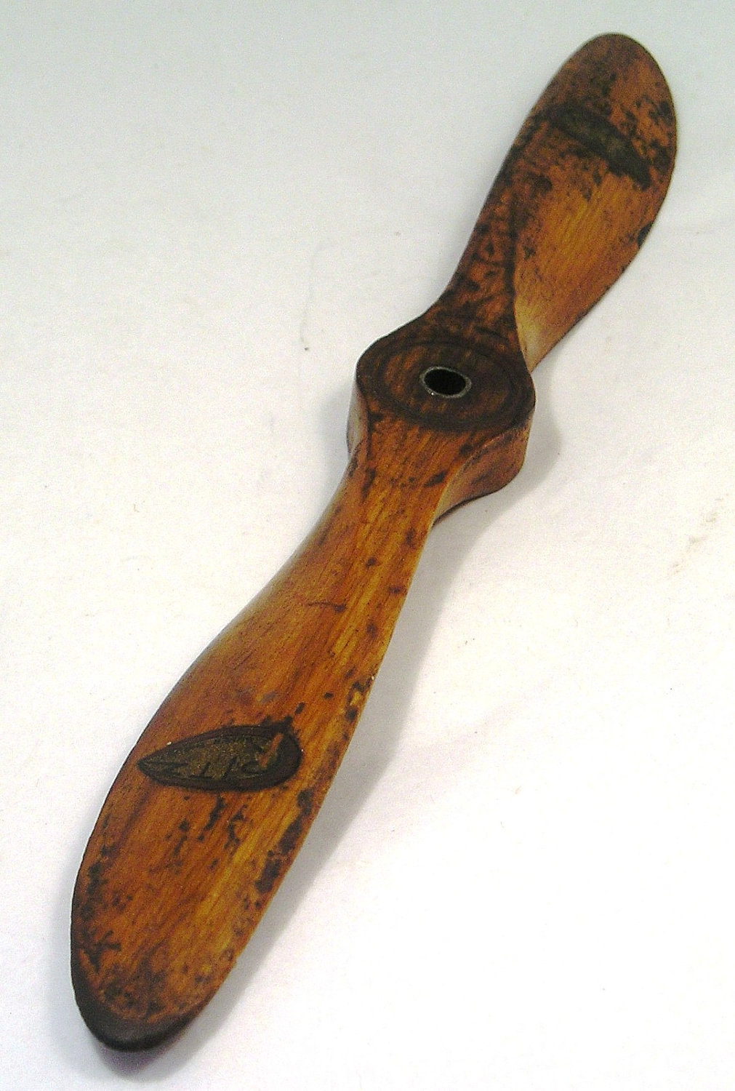
It is with pleasure and some trepidation that I respond to a request from Brother Yabut to put together some highlights of some of my past achievements as an undergraduate at Cal Poly, with a focus on the Mustang Aviation Club.

I was a "walk-on" 24 year old freshman who had just completed a four year apprenticeship as a machinist at Mare Island Naval Shipyard. No one in my family ever aspired to a college degree. At first I felt overwhelmed, but my background soon made many engineering labs available to me for extra-curricular activities. I arrived at Cal Poly with a pilot's license, approximately 250 hours of flight time logged, a NAUI scuba certification, a 1954 Chevy and a 1954 Triumph 6T motorcycle.

Since Cal Poly had an airport on campus, I discovered the Mustang Flying Club which consisted of a very tired Cessna 150 and an old WWII vintage Aeronica 7AC Champ. They were based at the SLO County airport. These planes were based at SLO county airport. I immediately joined and began giving rides to my new friends in the Aeronica Champ. I was tail-dragger qualified, having soloed a Piper Super Cub.

On one occasion, as I was doing a preflight inspection, a gentleman walked up and asked if I could take a passenger. I replied yes and told him to jump in. Our flight consisted of a trip over Avila Beach, up to Morro Rock, then to Hearst Castle, and back. Upon landing the gentleman congratulated me on a great flight and introduced himself as Mr. Alex Madonna. As we taxied up to the hanger, he pointed out his bright flamingo-pink Aero Commander on the tarmac.

Giving rides only intensified after that and it became obvious that virtually every young student passenger was very interested in pursuing flight training. This interest level ultimately led to the expansion of the Mustang Flying Club and acquisition of several new aircraft that were used for primary training purposes.

After my departure as club President in my sophomore year, it’s my recollection that the club was closed. Its demise came when a young male student pilot took a female friend for an illegal nighttime joyride and crash-landed the airplane into the jetty in front of Morro Rock.

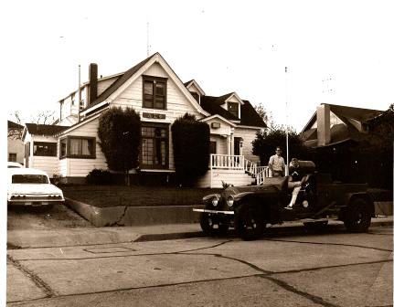
In my junior year, I expanded my social circle by pledging the Delta Sigma Phi fraternity on Palm Street. On becoming an active member and then Pledgemaster, I could hardly wait to get my hands on DSP's 1924 American LaFrance Pumper Fire Engine.

Unfortunately, it had become the victim of many unsuccessful attempts to make it run. After a complete teardown and machining of many critical parts, and completely rebuilding the original motor, I was justifiably proud of how well it ran. I remember many on-campus trips when we used the Fire Engine for socials and pledge recruitment. As Fire Engine Chairman I recall that hauling the crew out to Avila Beach for the bathtub races was a real highlight.

The Origin of Our Chapter's Al Capone Party
By John "Si'mon" Kerr, S'58

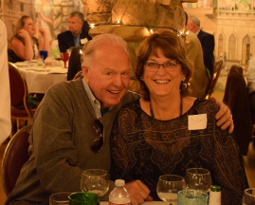
< Photo: John and The Lovely Dian Kerr

I checked with the main perpetrator of the "The Al Capone Party". In probably 1959, Sid "Tender" Nesbit (Fall '57), the Social Chairman of the Cal Poly Colony of Delta Sigma Phi hatched the idea of throwing a party called "Al Capone". Sid (the "Perp") and I recently chatted about the "Why's & Wherefores" of what became this annual event.

There was a Monday evening TV series in the 50's called the "Untouchables". It was a docudrama about Eliot Ness and his crew of government agents in the 20's and early 30's, during "Prohibition", battling "Rum Running Mobsters"; mostly the Chicago gang led by Al Capone! The show was so popular with the DSP denizens of 1134 Palm Street that many an "Active's Meeting" was cut short so that those interested could retire to the TV room to watch the show.

Sid conjured up the idea of putting on a party featuring that of a "Roaring 20's Speakeasy"! We rented the Odd Fellows Hall at the end of Dana Street. We had strict rules against drinking in the House! As many of us NOW know this became one of the reasons for the demise of Epsilon Rho's at "The New House"!

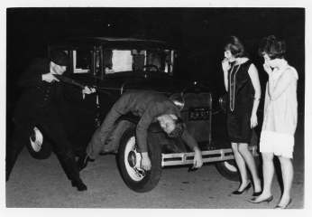
We don't remember where we got the telephone-booth-shaped-box that we placed in the foyer entrance to the main hall. We clad the space around the "booth" with a cardboard wall. Party goers, dressed in 20's style clothes and hats, would go into the "telephone booth", rap on the wall; a sliding "peep hole" would open; and the couple (showing their tickets) were allowed entrance. At some point (I can't remember if it was the 1st party); people would have to climb a small 6-foot slide with purloined mattress from 1134 at the bottom. Keg beer and wine were served only to those who were 21; others drank a non-alcoholic punch (strictly enforced...don't laugh!). In those days Pledges were kicked out and Active's had Pins pulled for violating House drinking rules!

(Photo: 1964 Al Capone) >

We hired a band who played 20's and 30's music (mostly Jazz). In subsequent years I parked my '34 Plymouth 4-door sedan outside a side door of the hall. A couple would get into the back seat (doors were "Suicide") and have a commemorative photo taken.

When I lived in 1134, when such parties were held; I usually retired that night (or early morning) on a wine & beer stained mattress!

But, of course "The Rest is History".

YITBOS,
JK

Invitation To Charity BBQ and Golf Tournament

37th Annual Cystic Fibrosis Benefit BBQ And Golf Tournament

Mike "Harpo" Roanhaus, S'70, again invites you to this charity golf tournament to be held Monday, August 9, 2021 at Pasatiempo Golf Club in Santa Cruz. The associated BBQ will be held the day before on Sunday, August 8th.

Please contact Harpo at Mike.Roanhaus@gmail.com or 650-465-5930.

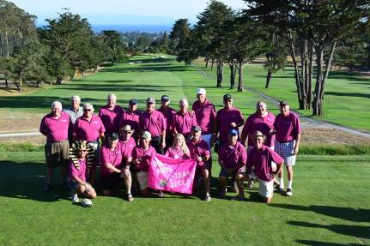
File photo from 2016 >

Back Row from left to right: Mike "Duffer" Jones, Rick "Ranger" Heinzen, Alan
"Big Daddy" Roth, Bob "Pele" Ferguson, Steve "Penny" Lane, Doug "Pooch"
Basch, Larry "TA" Everett, Jim "Ozzie" Nelson, Jim "Lurch" Larson, Noel
"Bull" Shutt, Jeff "Grobo" Weaver, Bob "Hots" Papazian

Front Row from left to right: Ben "Coco" Parcasio, Gene "Spanky" Blazick,
Tom "Woody" Brooks, Larry "Flash" Fritz, Becca Roanhaus, Mike "Harpo"
Roanhaus, Wayne "Dizzy" Kendrick, Greg "Deuce" Piers

Sadly, we have lost our dear Brothers Flash and Grobo.

Save These Dates

Convention: Thursday to Saturday, October 14-16, 2021, in LA

SLO Reunion: Thursday to Sunday, April 21st through 24th, 2022

One Class-Rep Sought For Each Pledge Class

Brothers:

We Delta Sigma Phi alumni from SLO-town are only as influential as we are "connected". As individuals we lack significant impact - but if we can become and stay connected we have significant influence.

Since our inception as a Colony in 1950 we have initiated over 160 classes! Your Alumni Association (AA) will never have the man-power to keep-up with the constantly-changing directory information. The alumni website's directory provides each alum with the means of checking his info, and submitting updates for inclusion (www.sloyitbos.com / Find Alumni). However, this isn't enough and we need a better solution.



Every brother counts! To keep our alums "in the loop" with newsletters, info on chapter restart and operations, reunion info, ACB meeting notices, etc., we need a Class Rep for every class!

Please talk with your PB's and nominate one man from your class. He will make sure the contact info for his PB's is remains current over time. He can look at our on-line info for his class and sending updates to Yabut (keeper of the directory)) aat CPatterson76@outlook.com.

AA Needs Your Support To Continue Our Work

AA EXISTS TO: AA (Alumni Assn.) exists to serve our alumni, chapter, and support our ACB and Fraternity. We are 100% alumni-funded and all-volunteer! We pay for memorabilia storage in SLO, newsletters, the alumni web site, directory - and we are trying to create a fund to assist future young brothers re-establish our new chapter. They will start with nothing - no savings, no big brothers, no upper classmen, but the need of leadership and other trainings.

AA volunteers have carefully packed and moved 68 years of fraternity memorabilia (paddles, etc.) to secure climate-controlled storage in SLO.

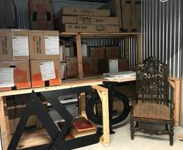

FIRST, please join AA with your $20 annual dues to grow our alumni base - and our voice with National.

Please add a donation to help cover our $2,500 annual storage cost and build a fund to help young brothers re-establish the chapter.

Give By Snail Mail:
Make Your Check Payable To: DSP EP Alum Assn.
Mail It To: Mr. Ray Calande (Mumbles, W’74) @ 1384 Rue Avati, San Jose, CA 95131

GIVE ELECTRONICALLY:
Go to PayPal.com, follow instructions, and give to: dsp_at_calpoly@att.net. We will assign your giving first to "Dues" and then to "Where most needed".

Thanks & YITBOS

